RBSP EFW
54AC14 DDD Test
Test Report

RBSP_EFW_TR_012

David Curtis, U.C. Berkeley

Document Revision Record
Rev. | Date | Description of Change

Distribution List
Name | Email
Michael Ludlam, Systems  Keith Goetz, PM  John Bonnell, Inst CoI  Jane Hoberman, BEB EE  Ron Jackson, QA | mludlam@ssl.berkeley.edu  goetz@umn.edu  jbonnell@ssl.berkeley.edu  jch@ssl.berkeley.edu  ronj@ssl.berkeley.edu

TBDs
Identifier | Description

Reference Documents
Ref | Doc Number | Title
[1] | RBSP_EFW_SYS_001 | EFW Requirements Matrix
[2] | 7417-9018 | RBSP EME requirements

Overview
The RBSP EFW IDPU BEB board contains drivers for the ACTEST signals which are distributed to the boom deployment units for pre-deployment end-to-end signal tests. These signals are subject to Deep Dielectric Discharge (DDD) generated in the harness are boom deployment units. This test is to verify that the signal driver can survive in the DDD environment of the RBSP mission, as described in reference [2], without additional protection. The DDD model for discharges from insulators onto signals includes a 3pF capacitor charged to 900V, discharging to the signal via 1500ohm (see figure 2 extracted from reference 2). A typical number of discharges over the life of the mission is ~1000.

The candidate driver used for the ACTEST driver is a National Semiconductor 54AC14FMQB (5962-8762401DA). 54AC parts are rated to Class2 for ESD (HBM to 2000V), so we expect it will survive DDD events. The driver has a series resistor (150 ohms) and capacitor (1nF 600V) on its output which is included in the test circuit (see Figure 2).

Figure 1. DDD model (from insulator) – from ref 2 fig 3.1.1-1 a.

Test Procedure
The plan is to verify that the 54AC14 is immune to damage from DDD events in the harness. This shall be done by generating simulated discharges into the output pins of a 54AC14 from the flight lot (5962-8762401DA, D/C 0606). The 54AC14 is tested in a ZIF socket with bypass capacitors on the power supply lines to a ground reference for the DDD event simulator. The bypass capacitors are equivalent to what is on the flight part, to provide a similar transient current flow. The inputs are grounded and the outputs have representative series resistor and capacitor (Figure 2). DDD pulses shall be applied to test point 1 and 2, corresponding to the two gates used to drive the ACTEST signals on the BEB. Testing will be done at +1500V and -1500V (>50% margin over the DDD event model), with the 54AC14 biased and unbiased. Before and after DDD exposure the part shall be characterized to determine if there is any damage.

Figure 2 – 54AC14 DDD Test Circuit

DDD Tester
A custom DDD tester was developed at SSL. It generates a series of simulated DDD pulses of programmable voltage. Figure 5 is a schematic of the tester. Note that it has 10pF capacitance to provide margin on the test, and to reduce the effects of stray capacitance in the tester. In addition, a HV supply, a pulse generator (to run the relay) and a counter were used as shown in Fig 6. The unit was calibrated against capacitive and resistive loads to verify performance.

Figure 5. DDD Tester schematic

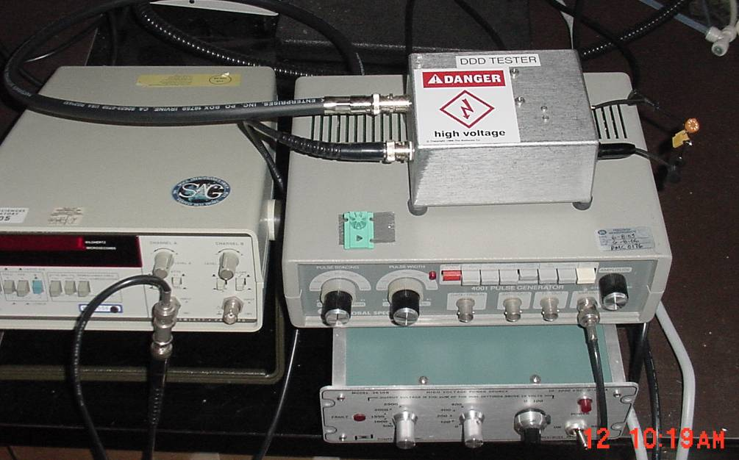
Figure 6. DDD Test setup

54AC14 Characterization
Prior to DDD testing and between DDD tests the 54AC14 was characterized using a custom test setup shown in Figure 7. For most tests Vcc was set to 5V. The following parameters were measured for the two gates to be tested:
Icc – supply current, unloaded
VOH – output high voltage (loaded by 511 ohms to ground)
VOL – output low voltage (loaded with 511 ohms to ground and 1Kohms to 5V)
Tplh – gate delay time input to output, low to high output transition, loaded by 511 ohms to ground and 47pF to ground.
Tphl – gate delay time input to output, high to low output transition, loaded by 511 ohms to ground and 47pF to ground
VOHX – output voltage with Vcc=0V and output pulled to +10V via 1kohm (output protection test)
VOLX – output voltage with Vcc=0V and output pulled to -10V via 1kohm (output protection test)

Figure 7 – Characterization Circuit

Test Results
The parts showed no change after DDD exposure.

During DDD exposure the gate output was checked with an oscilloscope (not connected for the 1000 simulated DDD events as the scope probe capacitance could attenuate the DDD pulse). A 45V 5ns transient was observed, indicating the pulses were being shorted by the 54AC14 protection diodes.

The part in this configuration is considered qualified for flight for DDD.

Appendix A - Test Results

